

De La Salle University

Gokongwei College of Engineering

Electronics and Communications Engineering Department

**LBYCP29 ExperimenT 7**

Submitted By:

**Jan Carlo D. Rabacca**

**Suzette Dela Cruz**

**Marc Chiu**

Submitted To:

**Engr. Melvin Cabatuan**

Date:

**October 28, 2015**

Multi-class Classification and Neural Networks

Jan Carlo D. Rabacca

11106344

Suzette Dela Cruz

11118113

Marc Chiu

11114525

# Introduction

A multiclass classification predicts the class where a given new data point belongs to. There are N number of different classes wherein each training point belongs.

A neural network is a “connectionist” computational system. It does not follow a linear path, but it processes information collectively in parallel throughout a network of nodes.

# Data and Results

## Dataset

## % Load saved matrices from file

## load('ex3data1.mat');

* 1. Visualizing the data

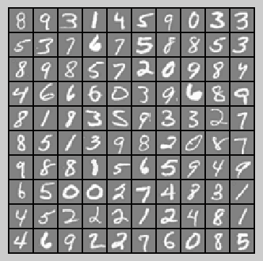

Figure 1

* 1. Vectorizing Logistic Regression

lrCostFunction.m

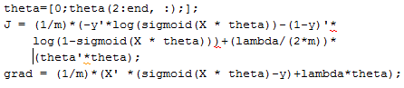

* 1. One-vs-all Classification

oneVsAll.m

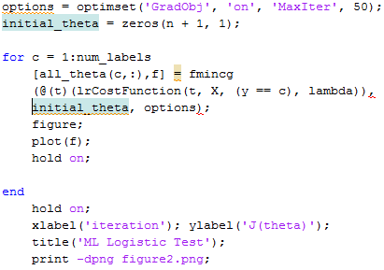

predictOneVsAll.m



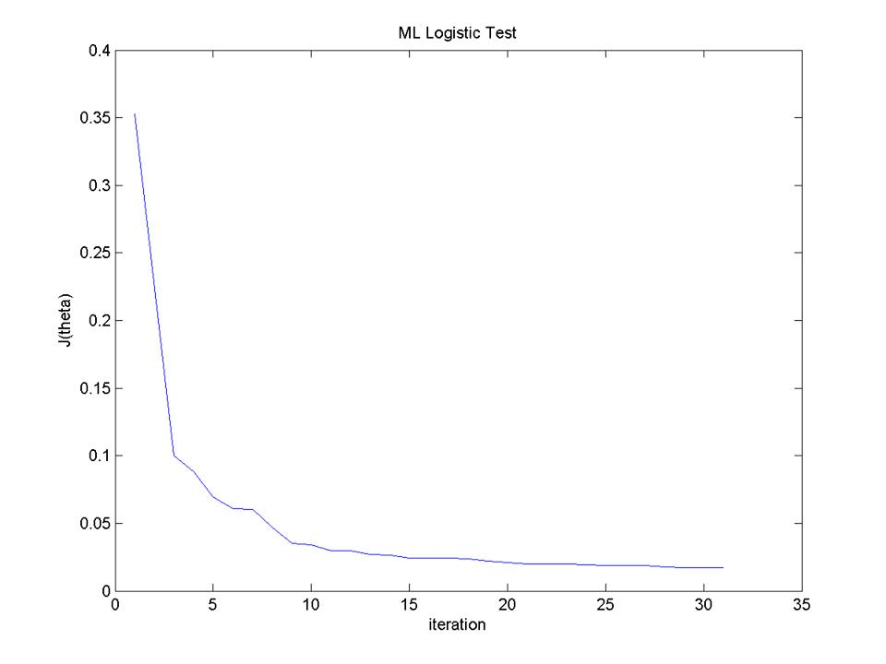

Figure 2 (J(ϴ) Plot)

Training Set Accuracy: 73%

2.1 Model Representation

% Load saved matrices from file load(‘ex3weights.mat’);



Figure 3

2.2 Feedforwarding Propagation and Prediction

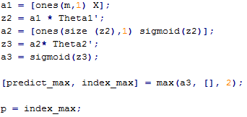

Training Set Accuracy: 97.52%

# Analysis and conclusion

The goal of this experiment is to use one-vs-all logistic regression and neural networks to recognize handwritten digits from 0 to 9. X is a 5000 (samples) by 400 (unrolled 20 by 20 image) matrix and y, a 5000-dimensional vector, contains the labels for the 5000 samples.

Using logistic regression on this set of data requires the use of 10 separate logistic regression classifiers, one for each digit from 0 to 9. In One-vs-all classification, all '0' samples is compared to all samples, marking all '0' samples with 1 and all non-'0' samples as 0. The same applies for '1' to '9' samples. The samples marked with 1 is used for training their respective logistic regression classifier. In one-vs-all prediction, for every input, a probability is calculated using the trained classifiers. The highest probability is thus taken as the classification of the input.

The neural network part of this experiment only covers the feedforward propagation and prediction. The trained network parameters (Theta1 and Theta2) were provided. This part also functions the same way as one-vs-all logistic regression that it returns the classifier (row index) of the highest related probability.

# REFERENCE

### [1] R, Rifkin. Class Lecture, Topic: “Multiclass Classification.” 46-5193, [Massachusetts Institute of Technology](http://web.mit.edu/), Feb. 25, 2008.

[2] D. Shiffman. (2012, December 13). The Nature of Code. (1st edition). [On-line] Available: http://natureofcode.com/book/chapter-10-neural-networks/ [Oct. 27, 2015].